**Ram sai kiran chintala**

**12594885**

**Assignment 1 makeup**

**Question 1:**

Below are the graphs and their outcomes.

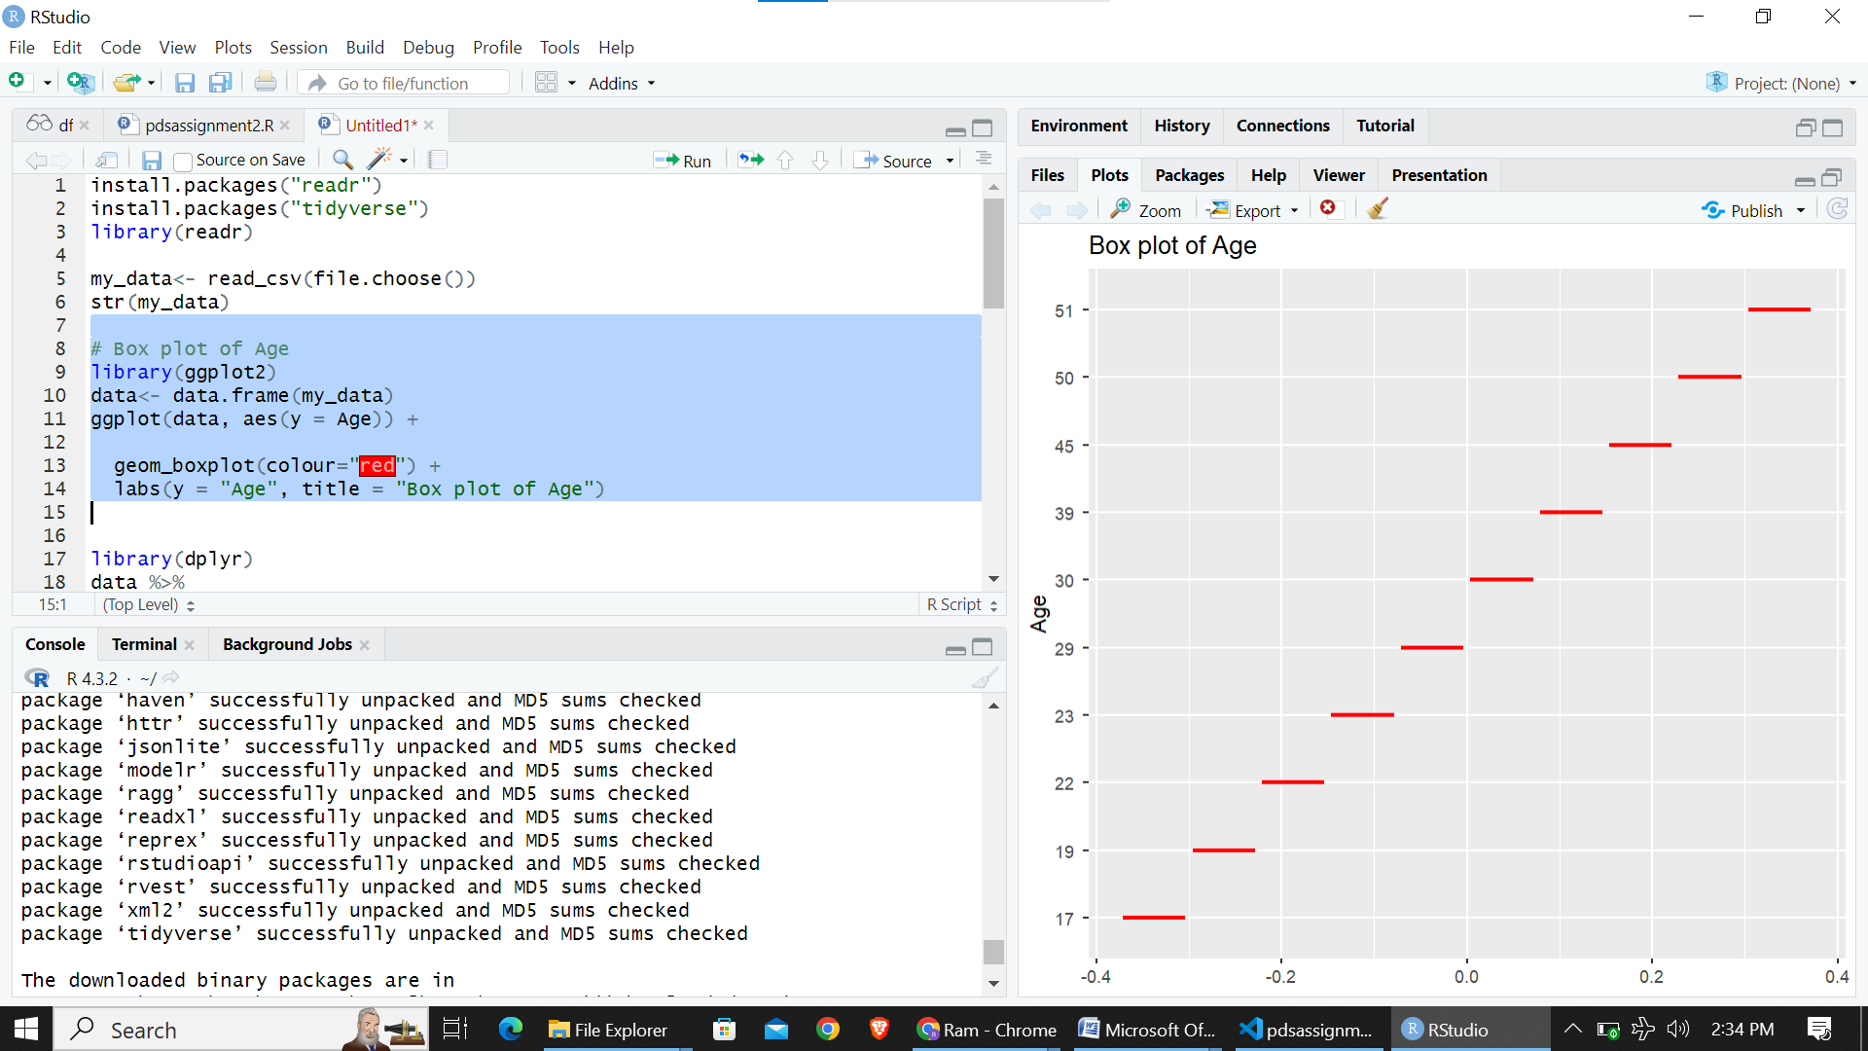

**Box plot of Age:**

This plot visually represents the distribution of ages in the dataset. The box plot includes key statistics such as the median, quartiles, and potential outliers.

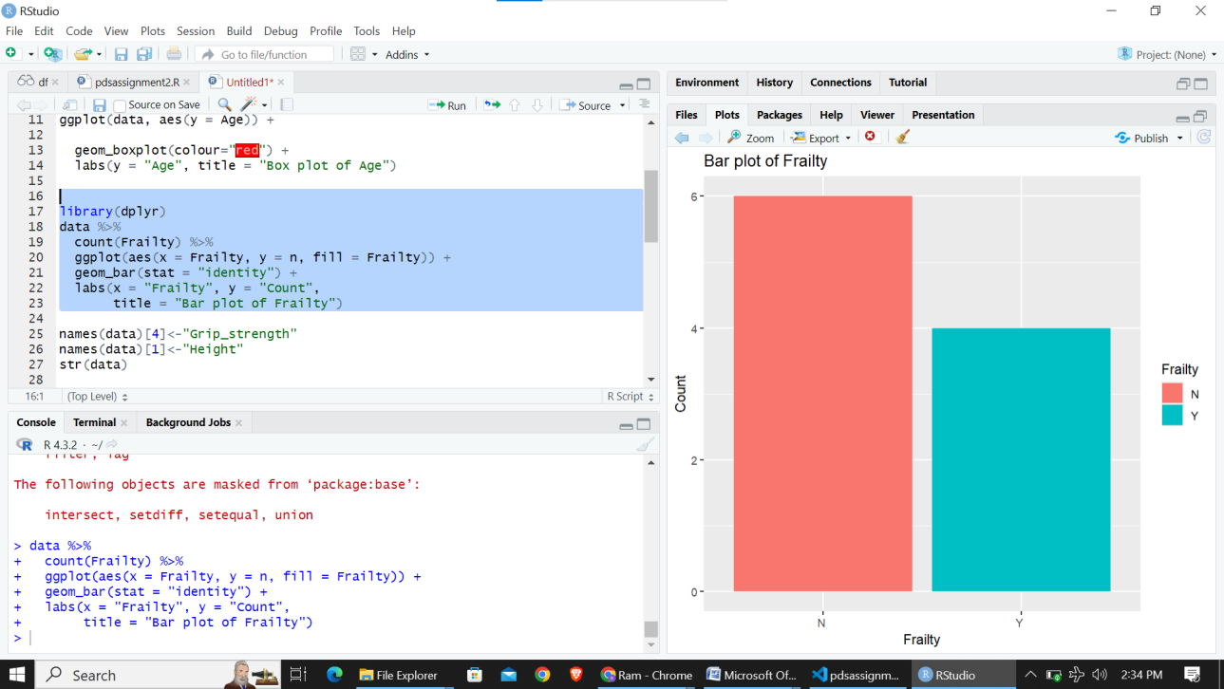

**Bar plot of Frailty:**

Displays the count of each Frailty category, offering a comparison of their prevalence. Different colors are used to represent distinct Frailty levels.

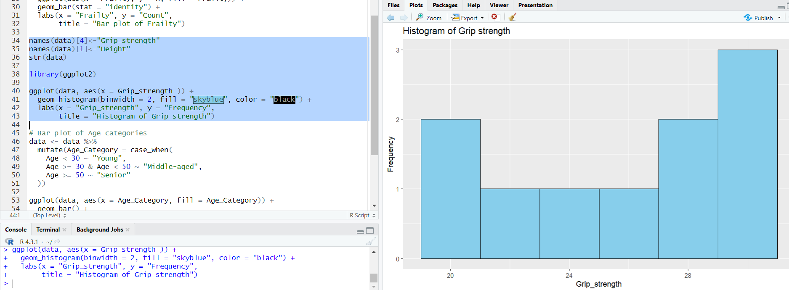

**Histogram of Grip Strength:**

Illustrates the frequency distribution of grip strength values in the dataset using a histogram. The binwidth is set to 2.

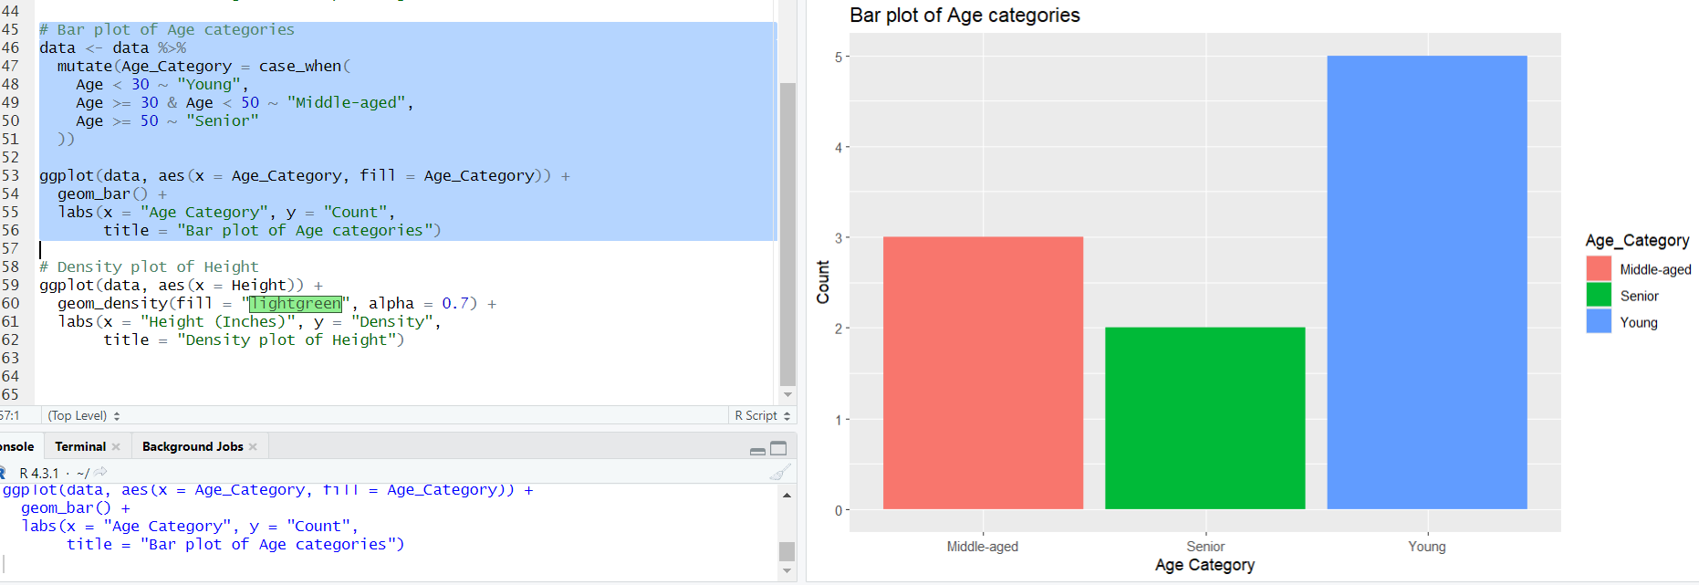

Bar plot of Age Categories:

This bar plot offers a concise summary of the age distribution across different life stages.

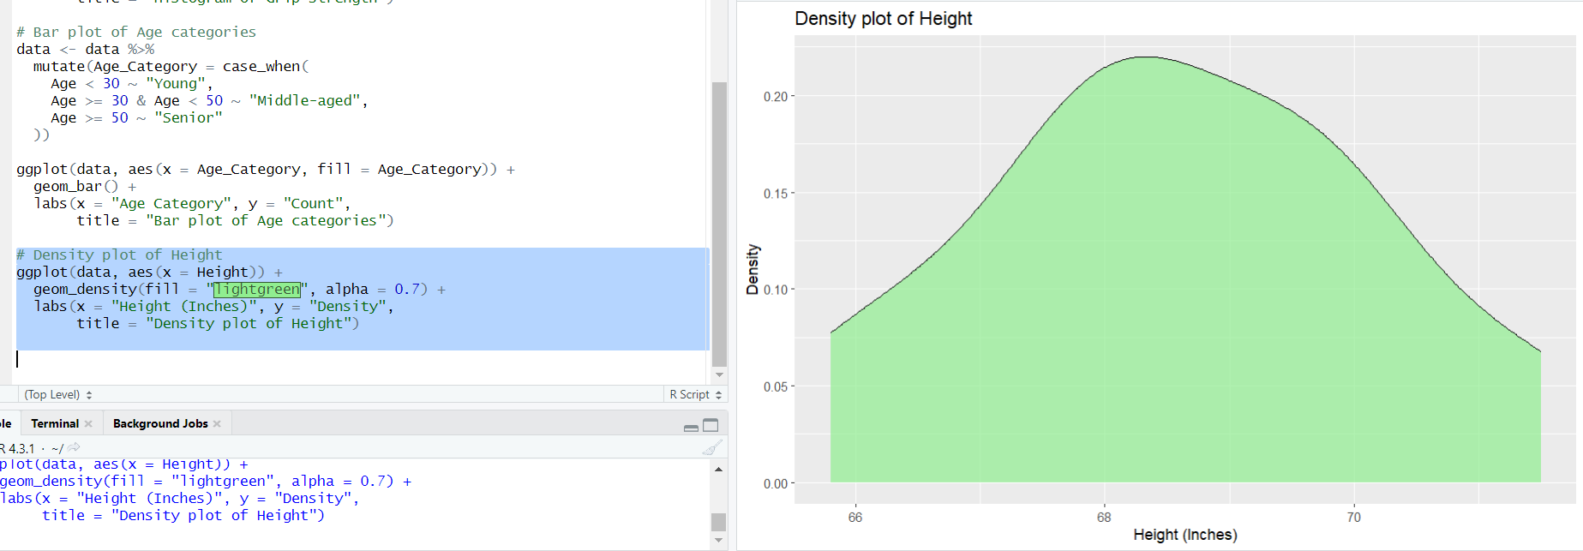

**Density plot of Height:**

Utilizes a density plot to visualize the distribution of heights in the dataset.

This shows the given data has women in the height range 55-65 are more in number.